LEARNING OBJECTIVES

1. **Understanding Analog vs. Digital Signals**:
   * Explain the difference between analog and digital signals.
   * Illustrate the concept of analog-to-digital conversion.
2. **Assessing ADC Quality**:
   * Evaluate the quality of analog-to-digital conversion using the following metrics:
     + Sampling rate
     + Quantization levels
     + Number of bits used for encoding
     + Dynamic range.

INPUT PORTS

* The input to this code is the analog signal from the sensor connected to the ADC channel (e.g., a temperature sensor or light sensor).
* The specific channel is selected by setting the address pins (ADDR_A, ADDR_B, and ADDR_C).

OUTPUT PORTS

* The output is the digital representation of the analog signal obtained after the ADC conversion.
* The converted value is stored in ADC_Value and output to P3.

LOGIC

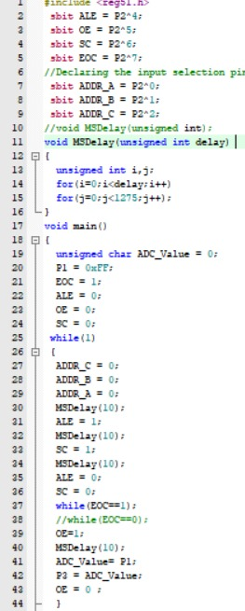

RESULT

The provided code snippet interfaces an analog-to-digital converter (ADC) with an 8051 microcontroller. It reads an analog signal from a sensor, converts it to a digital value, and outputs it. The specific ADC channel and sensor type would need to be configured for a complete system.